**Statistical Analysis**

In this project, we would like to investigate the effectiveness of violence on scenes in video games on children’s aggression level. The dependent variable is children’s aggression level and the independent variable is the extent of violence scenes in the video games. We exploited the Pearson Correlation test to find the correlation between two variables. Also, we have measured other variables, such as children’s pleasure and frustration levels and game familiarity levels of each game to test whether there are some other explanations for the final results. We are using correlation plots to illustrate the relationship between the game types and aggression level.

**Results**

Among the participants whose ages ranged from 6, 10 and 12, there was no significant correlation between the violence scene in different types of video games and children’s aggression level. The correlation tests were made separately in the three age groups while there was no difference in the results, which can be explained by the irrelevance between increase of age and aggression level.

According to the other related ratings on children’s pleasure level, frustration level, and game familiarity level in the dataset, there was a positive correlation between children’s pleasure about the game and the familiarity level (*r*(298)= .45, *p*=3.35 ). In other words, children were more likely to feel good when they played the game which they knew well. In addition, in order to measure the correlation between aggression level and violence scene in different game types, we used the Pearson Correlation test to find the p-value. The result showed that there was a moderate correlation between game types and violence scene and content(*r*(298)=-.34, *p=*1.33,  *r*(298)*=* -.30, *p*= 6.78).

**Figure 1**

*Correlation between different variables*

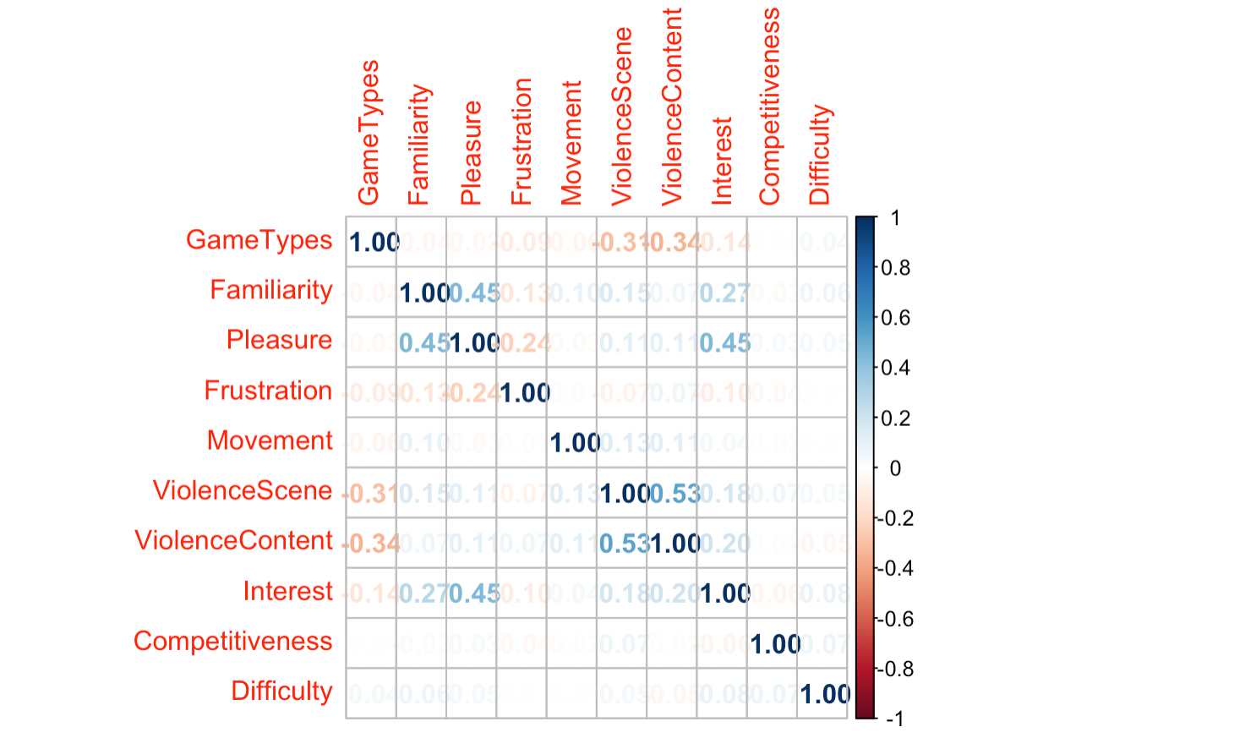

*Note.* The graph is an assemble of different variables we measured. In this graph, we mainly focus on how game familiarity is associated with children’s pleasure level and frustration level. It shows a positive correlation between pleasure and familiarity. And there is a weak correlation between frustration and familiarity.

**Figure 2**

*Violence scene and violence content and game types*

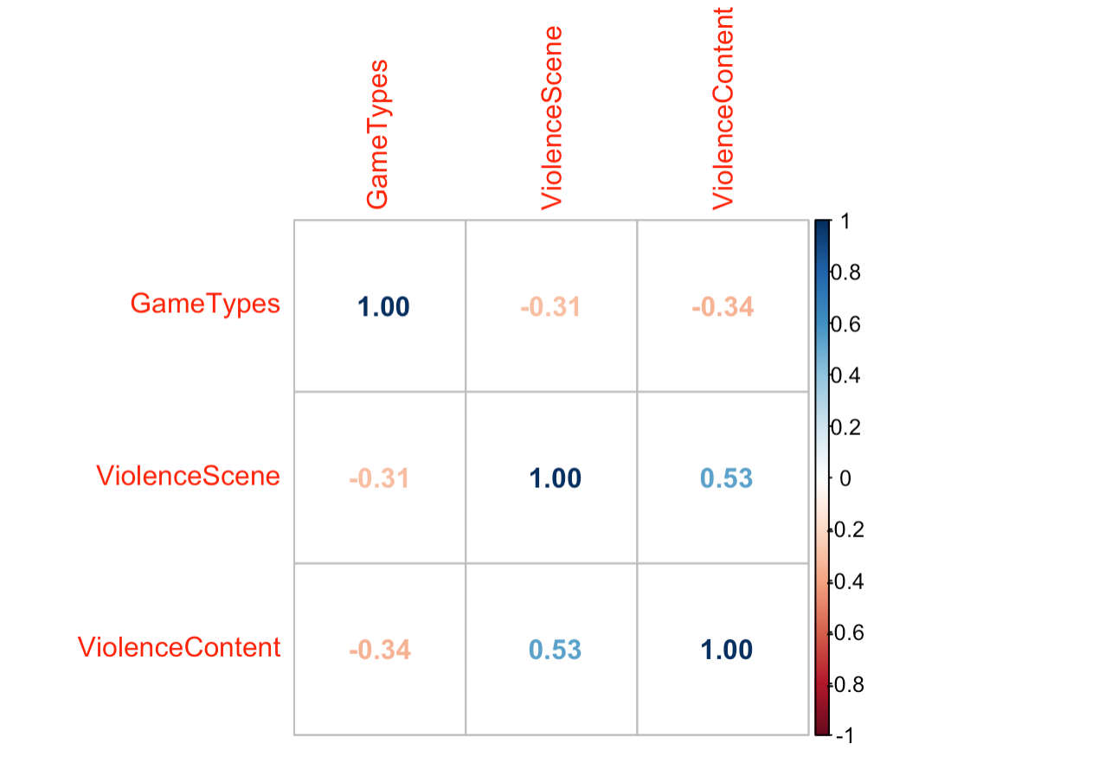

*Note.* It shows a moderate negative relationship between violence content and game types. And as well as the violence scene and game types.

**Figure 3**

*Children’s average rate of violence in different types of video games*

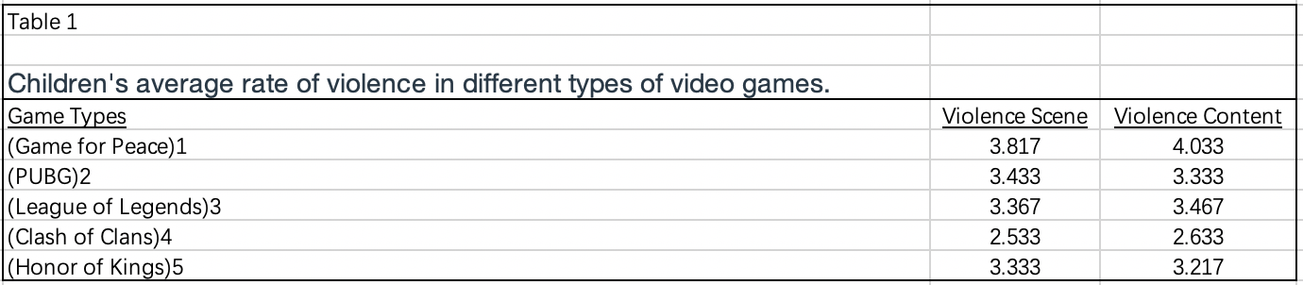

*Note.* The table shows children’s average rating on the violence level in different types of games. The rating scale is from 1 to 5.